Byron Center
Public School

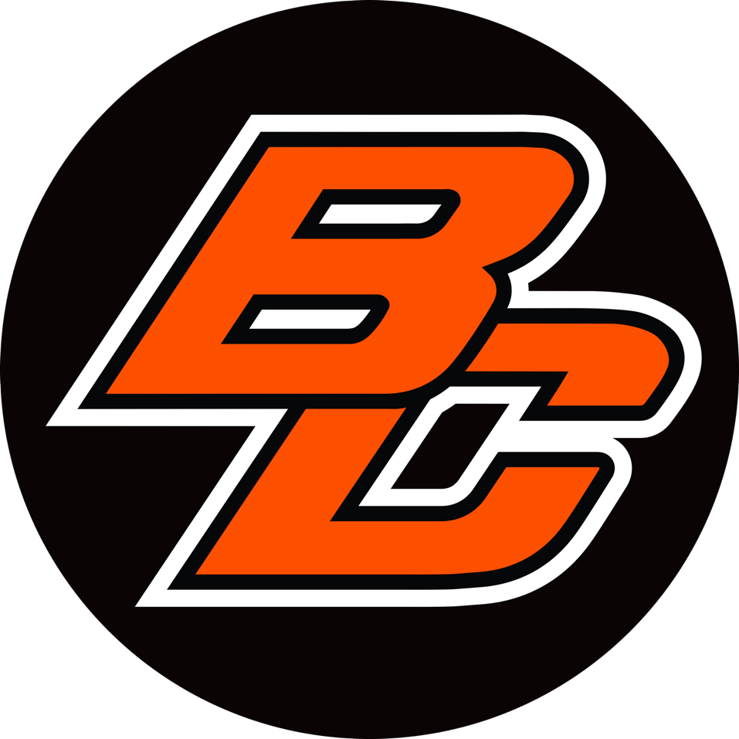

Acceptable Use Policy
and
One-to-One Program

Acceptable Use Agreement
The purpose of this Agreement is to grant access to and define acceptable use of the District’s technology resources. Technology Resources are any type of instrument, device, machine, equipment, technology, or software that is capable of transmitting, acquiring, or intercepting, any telephone, electronic, data, internet, audio, video, or radio transmissions, signals, telecommunications, or services.

In exchange for the use of the District’s technology resources either at school or away from school, you understand and agree to the following:

  - Your use of the District’s technology resources is a privilege that may be revoked by the District at any time and for any reason.

  - You have no expectation of privacy when using the District’s Technology Resources. The District reserves the right to monitor and inspect all use of its Technology Resources, including, without limitation, personal email and voice mail communications, computer files, databases, web logs, audit trails, or any other electronic transmissions accessed, distributed, or used through the Technology Resources. The District also reserves the right to remove any material from the Technology Resources that the District, at its sole discretion, chooses to, including, without limitation, any information that the District determines to be unlawful, obscene, pornographic, harassing, intimidating, disruptive, or that otherwise violates this Agreement.

  - The Technology Resources do not provide you a “public forum.” You may not use the Technology Resources for commercial purposes or to support or oppose political positions or candidates unless expressly authorized in advance by an administrator as part of a class project or activity. You may, however, use the Technology Resources to contact or communicate with public officials.
  - The District’s Technology Resources are intended for use only by registered users. You are responsible for your account/password and any access to the Technology Resources made using your account/password. Any damage or liability arising from the use of your account/password is your responsibility. Use of your account by someone other than you is prohibited and may be grounds for suspension from the Technology Resources and other disciplinary consequences for both you and the person(s) using your account/password.
  - You may not use the Technology Resources to engage in bullying, which is defined as: any written, verbal, or physical act, or any electronic communication, that is intended or that a reasonable person would know is likely to harm one or more pupils either directly or indirectly by doing any of the following:

      - Substantially interfering with educational opportunities, benefits, or programs of one or more pupils.

      - Adversely affecting the ability of a pupil to participate in or benefit from the educational programs or activities by placing the pupil in reasonable fear of physical harm or by causing substantial emotional distress;
      - Having an actual and substantial detrimental effect on a pupil’s physical or mental health; or

      - Causing substantial disruption in, or substantial interference with, the orderly operation of the school.

Use of other communication/messaging devices (including devices not owned by the District) to engage in bullying may be grounds for discipline under the District’s Code of Conduct/Handbook.

  - If you misuse the Technology Resources, your access to the Technology Resources may be suspended and you may be subject to other disciplinary action, up to and including expulsion. Misuse includes, but is not limited to:
- Accessing or attempting to access material that is “harmful to minors.” Material that is “harmful to minors” includes any picture, image, graphic image file, or other visual depiction that (1) taken as a whole and with respect to minors, appeals to a prurient interest in nudity, sex, or excretion; (2) depicts, describes, or represents, in a patently offensive way with respect to what is suitable for minors, an actual or simulated sexual act or sexual contact, actual or simulated normal or perverted sexual acts, or a lewd exhibition of the genitals; and (3) taken as a whole lacks serious literary, artistic, political, or scientific value as to minors.

- Accessing or attempting to access material that is unlawful, obscene, pornographic, profane, or vulgar.

- Accessing or attempting to access material that is inappropriate for minors. Material that is inappropriate for minors is defined as: visual depictions of material deemed obscene or child pornography, or to any material deemed harmful to minors.

- Bullying (as defined in paragraph E).

- Sexting, which includes, without limitation, possessing, sending, or distributing nude, sexually explicit, or sexually suggestive photographs, videos, or other visual depictions of yourself or another person.

- Vandalism, which includes, without limitation, any malicious or intentional attempt to harm, steal, destroy, or disrupt user data, school material, or school hardware or software.

- Hacking, which includes, without limitation, gaining or attempting to gain access to, modifying, or obtaining copies of information belonging to others or information you are not authorized to access.

- Unauthorized copying or use of licenses or copyrighted software.

- Plagiarizing: this includes the unauthorized distributing, copying, using, or holding out as your own, material that was written or created by someone else, without permission of, and attribution to, the author/creator.

- Posting or distributing confidential or inappropriate information meant to harass, intimidate, or embarrass others.

- Allowing someone else to use your account or password or not preventing unauthorized access to Technology Resources when leaving them unattended.

- Using or soliciting the use of, or attempting to use or discover the account information or password of, another user.

- Attempting to or successfully disabling security features, including technology protection measures required under the Children’s Internet Protection Act (“CIPA”).

- Misusing equipment or altering system software without permission.

- Commercial for-­‐profit activities, advertising, political lobbying, or sending mass mailings or spam. However, you may contact a public official to express an opinion on a topic of interest.

- Using the Technology Resources in any way that violates any federal, state, or local law or rule, or the District’s Code of Conduct/Handbook.

  - You must promptly disclose to your teacher or other school employee any content you view or receive over the Technology Resources that is inappropriate or that makes you feel uncomfortable, harassed, threatened, or bullied, or that contains sexually explicit content. You should not delete such content until instructed to do so by a staff member.

  - It is the policy of the District, as a recipient of certain federal funds, to monitor the online activities of its minor students and provide technology protection measures on its computers with internet access designed to prevent minors from accessing visual depictions that are (1) obscene, (2) child pornography, or (3) harmful to minors.

  - It is the policy of the District to prohibit its minor students from (1) accessing inappropriate matter on the internet; (2) engaging in hacking or other unlawful online activities; and (3) accessing materials that are harmful to minors. It is also the policy of the District to educate students about cyber bullying awareness and response and about appropriate online behavior, including disclosing, disseminating, or using personal information and safely and appropriately interacting with other individuals in social networking websites, chat rooms, by e-­‐mail, and other forms of direct electronic communications.

  - The District does not guarantee that measures described in paragraphs H and I will provide any level of safety or security or that they will successfully block all inappropriate material from the District’s students. You agree that you will not intentionally engage in any behavior that was intended to be prevented by paragraphs H and I.
  - The District does not warrant or guarantee that its Technology Resources will meet any specific requirement, or that they will be error free or uninterrupted; nor will the District be liable for any damages (including lost data, information, or time) sustained or incurred in connection with the use, operation, or inability to use the Technology Resources.

  - You are responsible for the proper use of the Technology Resources and will be held accountable for any damage to or replacement of the Technology Resources caused by your inappropriate use.

CARE AND MAINTENANCE OF STUDENT DEVICES (DEVICE).

- Do not attempt to gain access to the internal electronics or repair your device. If your device fails to work or is damaged, report the problem to your school’s Tech Center as soon as possible. Device repair/replacement options will be determined by school administration. You may be issued a temporary device or other materials until your device is working properly or replaced.

- Never leave a device unattended. When not in your personal possession, the device should be in a secure, locked environment. Unattended technology will be collected and stored in the school’s Tech Center.

- Never expose a device to long term extremes in temperature or direct sun light. An automobile is not a good place to store any technology.

- Technology does not respond well to liquids. Avoid applying liquids to the device. The device can be cleaned with a soft, dry, lint-free cloth. Do not use window cleaners, household cleaners, aerosol sprays, solvents, alcohol, ammonia, or abrasives to clean the device. Use of unapproved cleaners may remove the protective film covering the screen or face of the device.

- School owned technology MUST remain in the provided case at all times. The student will be charged for any damage to the device outside the school-issued case.

- Avoid placing weight on the device.

- Never throw or slide any technology.

- Your device comes with ports for charging and other accessories. Care must be exercised when plugging and unplugging accessories. Student-issued device accessories are the responsibility of the student.

- District owned devices have the ability to be remotely located. Modifying, disabling or attempting to disable the locator is a violation of the acceptable use policy and grounds for disciplinary action.
- Each device has a unique identification number and at no time should the numbers or labels be modified or removed.

- Do not lend your device to another person. Each device is assigned to an individual and the responsibility for the care of the device rests solely with that individual.

- Your device is an electronic device and care must be exercised when handling. Never throw a book bag that contains a device. Never place a device in a book bag that contains food, liquids, heavy, or sharp objects.

- Your device is designed for daily use; therefore, each device must be charged and ready for use each school day. Your device/s should be charged at home.

DEVICE REPLACEMENT COST
Chromebook $400
iPad $350

INSURANCE

Byron Center Public School has insurance setup for parents who wish for the devices to go home during the school year. The insurance is mandatory if the device is to go home after school hours.

Insurance Cost
Chromebook/iPad Insurance
Full Cost $40
Reduced Lunch $25
Free Lunch $15
Insurance Deductibles
Chromebook
First Repair Free
Second Repair $30
Third Repair $60

Provides coverage for Accidental Damage such as drops, falls, liquid spills, power surge and more.
- Provides protection against perils that cannot be covered by warranties or service contracts. These include: theft, burglary, robbery, vandalism, fire, flood, lighting, wind, and hail
- In the event of any claim, the student must report the incident to the school within 10 days. The student must also provide a detailed description of the events including how, where and when the loss occurred.
- In the event of a theft, a copy of the police report is required. The report must include the make, model and serial numbers of the stolen computer. Please work with the Technology department to obtain this information.
- Power adaptors and other peripherals are not covered by insurance.

- In the event of theft, loss or damage due to intentional abuse or misuse, it is the parents’/guardians’ responsibility to cover the device cost.

DAMAGED, LOST, OR STOLEN DEVICES

- In the event that a district-issued device is lost or stolen, the student and parent/guardian should immediately notify the school administrator. The filing of a police report by the parent/ guardian is mandatory for insurance claim processing. In the absence of a police report, the parent / guardian will assume responsibility for the full replacement cost.
- In the event that a police report is filed for a lost or stolen device, Byron Center Public Schools may aid the police in recovering the device. All devices are tagged with an asset label. The label is not to be removed from the device.

DISTRIBUTION OF DISTRICT TECHNOLOGY
- All District owned technology devices will be formatted by Byron Center Public Schools.
- An individual device will follow the student throughout the student’s career at Byron Center Public Schools.
- A parent/guardian may choose not to have their child participate in the take-home program by completing the forms attached and returning to the main office. In this event, students will be issued a device, but will not be able to take the device home. Students who do not participate in the take-home program will pick up and return their device to an area designated by the building principal on a daily basis. It is the student’s responsibility to pick up their device at the beginning of the day and drop it off before they leave for home. Byron Center Public Schools cannot guarantee equal access to materials and/or quality of materials to students opting out of the take-home program.

- All devices will be collected at the end of the school year. Devices not turned in by the last day of school will be treated as lost or stolen, which may include additional fees and possible legal action.

- Students who leave Byron Center Public Schools during the school year must return their device, along with any other accessories when they leave the district. Failure to return a device in a timely fashion may result in legal action or payment in full.

STUDENT USE OF DISTRICT TECHNOLOGY
- All District owned technology is the property of Byron Center Public Schools and as a result may be seized and reviewed at any time. The student should have NO expectation of privacy of materials found on any District owned technology or a school supplied or supported email service.
- Devices come equipped with a camera and video capacities. As with all recording devices, it is expected that students will ask permission before recording an individual or group of Individuals. Students must obtain school permission to publish a photograph or video of any school related activity.
- Students are responsible for bringing their device to school every day unless otherwise directed by a staff member. Failure to bring the device or any other class material(s) does not release the student from their responsibility for class work. If a student repeatedly fails to bring materials to class, including the device, the student will be subject to disciplinary action.
- It is the student’s responsibility to bring their device to school fully charged. A student’s repeated failure to bring their device charged may result in disciplinary action.
- Games, music, videos, and sound use, while at school, will be at the discretion of the classroom teacher and building administrator.

- The device affords limited electronic storage space. As with all electronic files, it is good practice to back up, duplicate, or archive files to an independent storage space. Students should use their Google Drive account to store all documents.

- The District issued device is designed as a tool for learning; misuses of the device may result in disciplinary action.

- All students should recognize and guard their personal and private information. While on the Internet, students shall not reveal personal information, including a home address or phone number, or the address or phone numbers of other students.

- A student should not share their personal account

- Byron Center Public Schools expects students to take their device home at night for class work and recharging. All care; handling and appropriate use that is in effect during the school day shall extend to the use of the device at home.

- Byron Center Public Schools makes no guarantee, written or implied, that materials on the device, including student work, will be safe from deletion or corruption, accidental or otherwise. Backing up files to the District servers is recommended.

- Parents / guardians have the right to limit use of the device at home.

COPPA AND CIPA - VERIFIABLE PARENTAL CONSENT

In order for Byron Center Public Schools to continue to be able to provide your student with the most effective web-based tools and applications for learning, we need to abide by federal regulations that require a parental signature as outlined below.

Byron Center Public Schools utilizes several computer software applications and web-based services, operated not by Byron Center Public Schools but by third parties. These include Google Apps, Apple ID, Moodle, Edmodo, Schoology, Zoom and similar educational programs.

In order for our students to use these programs and services, certain personal identifying information, generally the student’s name and email address, must be provided to the web site operator. Under federal law, these websites must provide parental notification and obtain parental consent before collecting personal information from children under the age of 13.

The law permits schools such as Byron Center Public Schools to consent to the collection of personal information on behalf of all of its students, thereby eliminating the need for individual parental consent given directly to the web site operator.

This form will constitute consent for Byron Center Public Schools to provide personal identifying information for your child consisting of first name, last name, email address and username to the following web-operators: Google, Follett, DeMarque, B.E. Publishing, Apple, Zoom and to the operators of any additional web-based educational programs and services which BCPS may add during the upcoming academic year.
This form will constitute that as a condition of your child’s use of the Technology Resources, you release the District and its board members, agents, and employees, including its internet service provider, from all liability related to my child’s use or inability to use the Technology Resources. You also identify the District and its board members, agents, and employees, including its Internet Service Provider, for any fees, expenses, or damages incurred as a result of my child’s use, or misuse, of the District’s Technology Resources.

You authorize the District to consent to the sharing of information about my child to website operators as necessary to enable your child to participate in any program, course, or assignment requiring such consent.

You understand that data your child sends or receives over the Technology Resources is not private. You consent to having the District monitor and inspect your child’s use of the Technology Resources, including any electronic communications that your child sends or receives through the Technology Resources.
You understand and agree that your child will not be able to use the District’s Technology Resources until this Agreement has been initialed and signed by both you and your child.
Please be advised that without receipt of the attached initial/signature form, your enrollment package will not be considered complete as Byron Center Public Schools will be unable to provide your student (s) with the resources, teaching and curriculum offered by our learning program.

Student / Parent Agreement:
This Agreement is entered into on: (Date)

This Agreement is between ("Student” or “User”) and Byron Center Public Schools

By signing the attached Student/Parent Agreement sheet, you agree to the above statements listed in the Acceptable Use Policy and all rules and regulations that may be added from time to time by the District or its internet service provider.

You also agree to follow all rules in the District’s Code of Conduct/Handbook.
As a condition of using the Technology Resources, you agree to release the District and its board members, agents, and employees, including its Internet Service Provider, from all liability related to your use or inability to use the Technology Resources.

You understand that data you send or receive over the Technology Resources is not private. You consent to having the District monitor and inspect use of the Technology Resources, including any electronic communications that you send or receive through the Technology Resource

Deployment Options
BCHS will have a student device available for every student in the fall. However, we want to give the parent the option to decline a student machine for home use for students in grades 5th-12th. Students in grades K-4th devices will stay at school unless there is a need determined by the school for the devices to go home.

Option 1: Take Home (Recommended BCPS)
Cost: Insurance Cost
My Student may take the device home and use this as their own.

Option 2: Stay at School
Cost: No Cost
My Student may not take the device home and should leave the device at school each night. I understand that it is the responsibility of my Student to check this in and out each day into the Tech Center.

SIGNATURES REQUIRED:

Student Signature: Date:
(Signatures Required)

Parent/Guardian Signature: Date:
(Signatures Required)

